2024 Summer Reading Program Registration Form

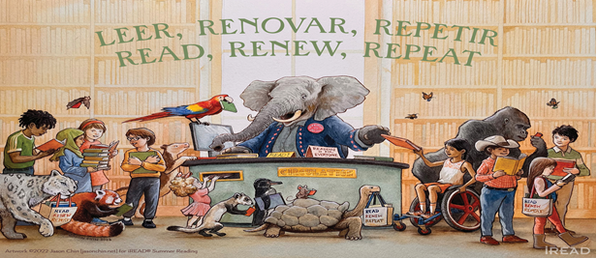Name:________________________________________

Address:_____________________________________

Phone:_______________________________________

Parent Email:________________________________

Age: ____ Grade(equivalent) going into:_____

I give permission for the Summer Reading Program Directors to photograph my child for the purpose of promoting the summer reading program.

YES_____ or NO______

**Parental** **Signature (Required): ______________________________________**

**________________________________________________________________**

For library use only: Programs attended: 1 2 3 4 5 6 7 8

2024 Summer Reading Program Registration Form

Name:________________________________________

Address:_____________________________________

Phone:_______________________________________

Parent Email:________________________________

Age: ____ Grade(equivalent) going into:_____

I give permission for the Summer Reading Program Directors to photograph my child for the purpose of promoting the summer reading program.

YES_____ or NO______

**Parental** **Signature (Required): ______________________________________**

**________________________________________________________________**

For library use only: Programs attended: 1 2 3 4 5 6 7 8